Physical Education (Monday and Tuesday-subject to change)
Tennis (prostars)
Cricket (prostars)
Athletics – running and Jumping focus

Religious Education
L2.7 BARHMAN/ATMAN
What do Hindus believe God is like?
L2.8 BARHMAN
What does it mean to be Hindu in Britain today?

PSHE and citizenship
Su1: It’s My Body (Health & Wellbeing)
My happy minds: Appreciate (year 3)
Su2: Growing Up – PINK (Health & Wellbeing)
My happy minds: two units Relate (Year 3) Engage (Year 3)

Summer 2025
Year 3 & 4
Romans
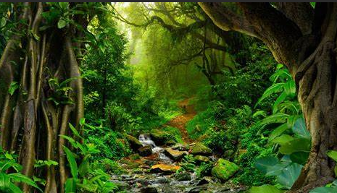
English
Story of the term
The Barnabus Project by Terry Fan
The Great Kapok Tree by Lynne Cherry
Grammar
Superlatives and comparatives
Determiners
Tense
Modal Verbs
Fronted adverbials

Writing
Climate Action (Magazine article)
Out there in the wild (Poetry)
A true story of the three little pigs (traditional tales with a twist)

Maths White Rose Maths
Time,
Money
Shapes
Decimals
Statistics
Positional language
KIRFs
Year 3
Know multiplication and division facts for 2, 5 and 10x
Know all multiplication and division facts for 3x, 6x and 9x table.
Year 4
Know multiplication and division facts for the 11 and 12x
Know all number bonds for £1 using decimal notation
Value- Perseverance

Science:
Health and movement
Eating and digestion
Topic
Geography:
The Rainforest
History
The Maya
Design technology
Seasonal Foods
Art
Telling Stories Through Making
Drawing, Sculpture, Sketchbooks Computing – Mrs Haroun
French- Miss Briggs

